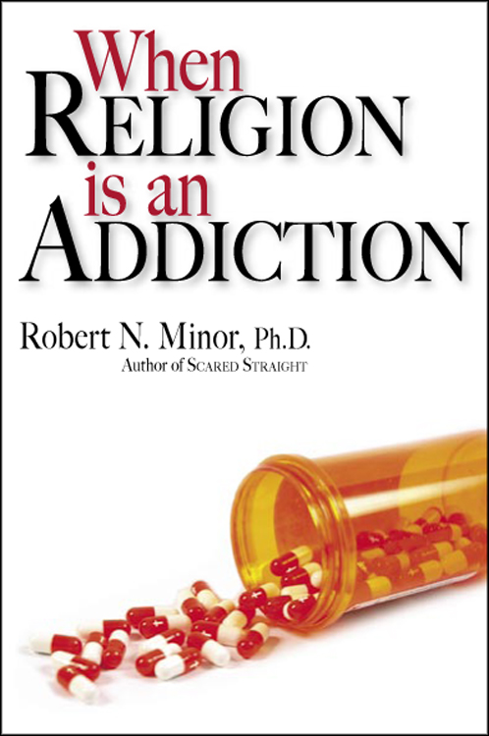
Sample Interview Questions about

When Religion Is an Addiction
By Robert N. Minor, Ph.D.

HumanityWorks! (St. Louis), August 2007

1. Books that criticize religion are bestsellers these days -- Time magazine calls it “an atheist literary wave.” You both appreciate that but are also concerned about their effect on what you’re calling addictive religion. Explain that.

2. The “When” is important in your title and in the whole book. You really want to make it clear that you’re not saying that all religion is an addiction – I think of the famous quotation from Karl Marx, “religion is the opiate of the people.” What you’re arguing is that religion can, and often does, function as an addiction for a lot of people. Why is that distinction important to you?

3. Explain what you mean when you say religion functions as an addiction for many people. Am I right that you estimate about 20% of the US?

4. You spend a bit of time in the final chapter distinguishing between non-addictive and addictive religion – and say it’s important to do that. It’s not so much based on what a religion believes. Would you tell us how we might do that?

5. You trace the history of how right-wing Christianity moved from a private world-rejecting position with little interest in politics to its current full-blown political involvement and its pursuit of victories with one initiative after another. You write that religious addicts were “ripe for the picking” by economic conservatives. Would you describe that change and how it fits with religious addiction?

6. Even though you’re talking about the thinking and activities of addictive religion and focusing on extreme right-wing Christianity, you don’t write to the people you’d understand as addicts. You’re writing to those you call the “liberal enablers.” Why did you decide to write to them? Did you want both the right-wing and left-wing to get angry with you?

7. Which brings up an important point you pick up from Ann Wilson Schaef’s work – our society thrives on addictions? Tell us more about that.

8. Your book points out a relationship between sexual addictions and religious addictions. We certainly hear a lot about religious and political leaders who’ve been out-spoken against various types of sexual activity getting caught with their pants down, so to speak. You write that the relationship goes back all the way to St. Augustine.

9. Even though your book is written for both religious and non-religious people who have to deal with addictive religion, and will probably be considered an attack on religion, it actually isn’t anti-religion. Your acknowledgements at the end of the book recognize a number of ministers and religion professors. In fact, a CD of “When Religion Is an Addiction” available on the web is actually a two-part sermon you gave at a Kansas City church. How are people reacting to the book and where are you on the religious to non-religious spectrum?

